Before writing any code, we decided to all agree on a common design for our website and determine our workflow so we could collaborate and synchronise between each other. Our previous module incorporated Miro as a way to gather ideas and visualise them, so we all agreed it would be a good tool to settle on a core idea for the website. As per the specification our website should feature;

- animation

- validation

- cookies/LocalStorage

What types of websites make use of these elements? We began researching and determined the best use of these elements would be featured in an online marketplace, a storefront that would be responsible for handling customer details such as location, email or phone numbers. It would also be expected to store and process payment information. Broadly speaking, we can feature animation on the homepage, validation on the payment processor and cookies on the login page.

With the backend conceptualised, what online marketplace would be expected to make good use of a modern, friendly user interface? We decided to focus on something that caters to a specific market; having a general web store (ie. Amazon) would be too broad and complex for this assignment, and would involve too much time spent on gathering assets and setting categories when only a few of each should be efficient. Abhi settled on the idea of a used car dealership – the scope of content is kept small while allowing us to focus on modern elements such as animations and accessibility. His knowledge of cars also make our job of setting categories and gathering car images/details easier.

I set out to research common elements that would be found on car dealership websites and how they are navigated. Screenshots were gathered of a few dealership websites, preferably ones with a clean look and low complexity as we aren’t planning to incorporate every feature. Local dealerships had a common design language with categories kept at the top of the page at all times, with the content kept below. Animations are simple but effective which would make navigation and accessibility easier. When gathering assets for the website we aimed to keep everything consistent – colour schemes, the website’s general layout, and size and style of images.

Here are the websites we referenced;

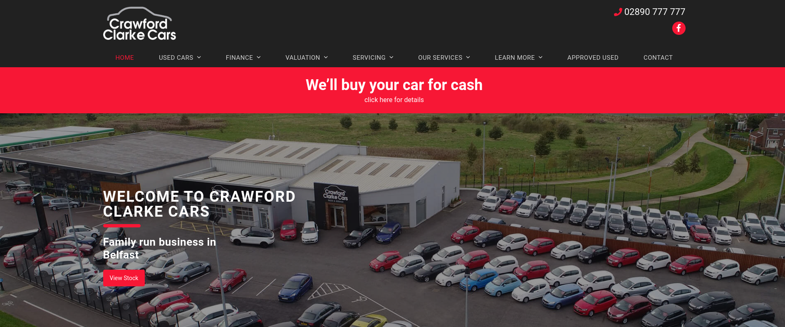https://www.crawfordclarkecars.co.uk/

[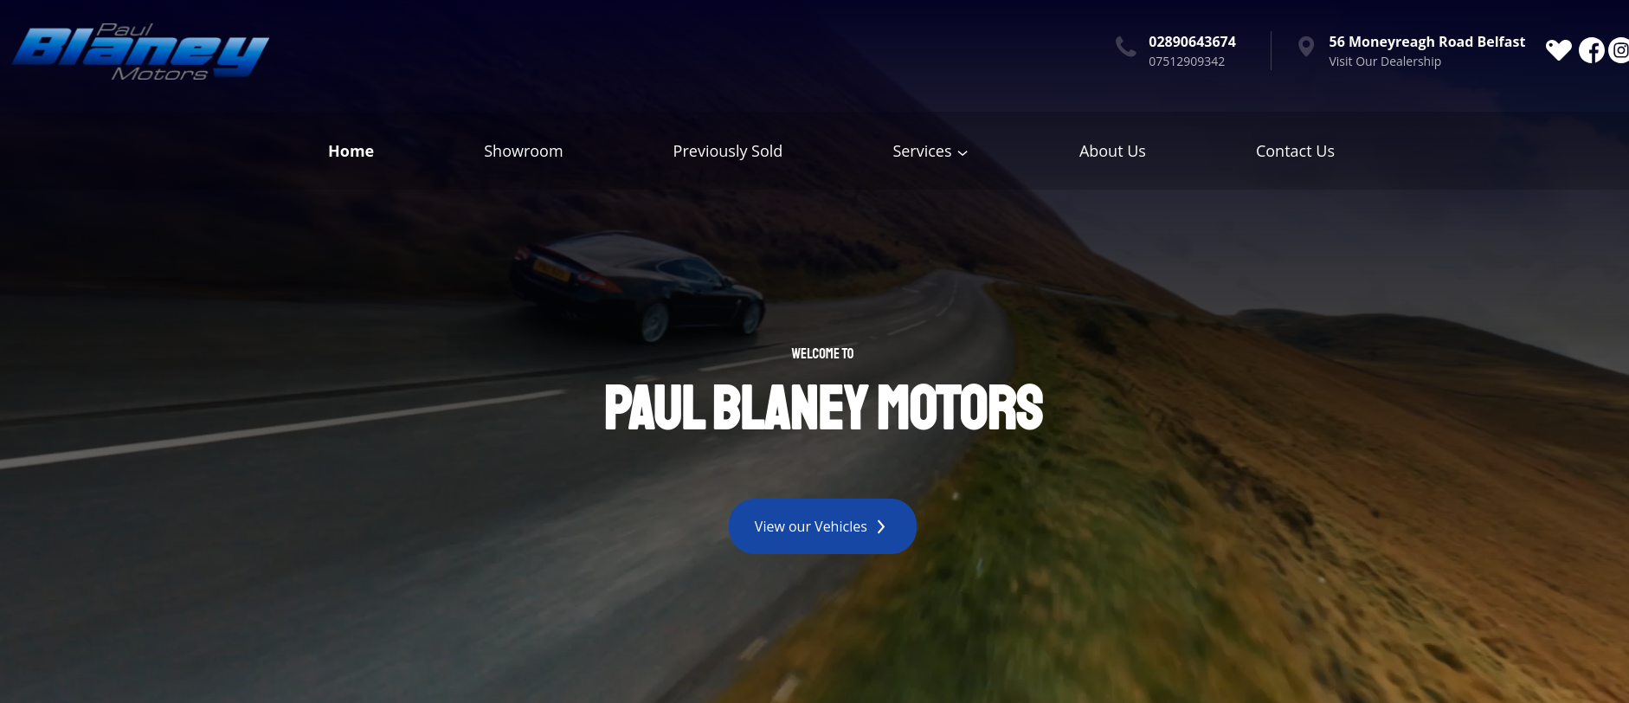](https://www.paulblaneymotors.com/)https://www.paulblaneymotors.com/

[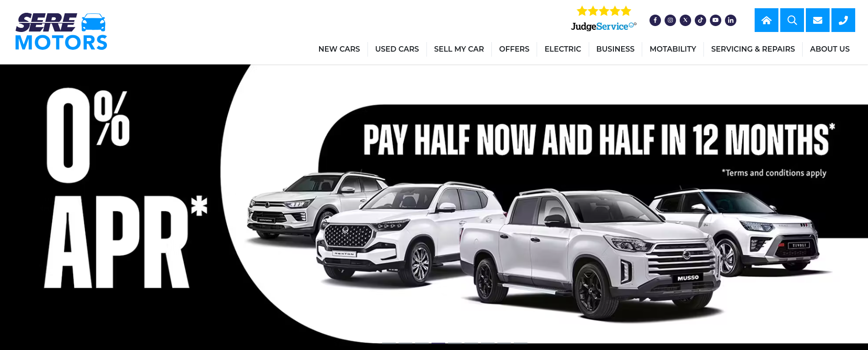](https://www.seremotors.com/)https://www.seremotors.com/

We also needed a way to synchronise assets and code between each other. Originally we settled on a Visual Studio plugin called LiveCode but had issues getting it to work on everyone’s machine. We finally settled on using GitHub due to its version control and commit history, allowing us to track who contributed to which piece of code or assets. Any unwanted changes could also be reverted if needed. The only concern with this approach was making sure everyone would commit their changes manually so no work would be lost or replaced.

We could now conceptualise the layout of the website. Again, we used Miro to determine how the site will be navigated and which categories would be present.

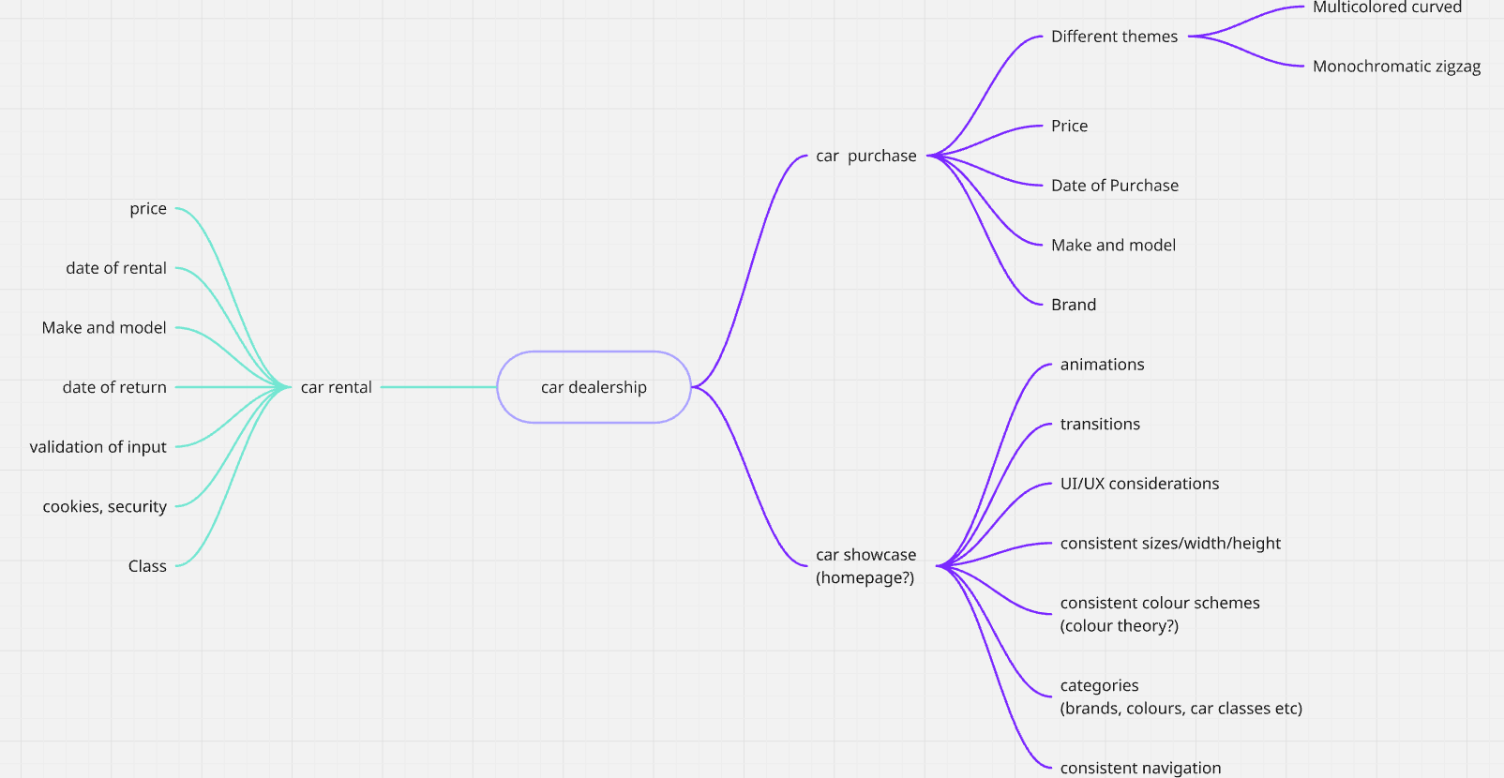  
After this we were ready to start coding. Nathan was not present during our first meet but still coded his own index layout while Abhi and I conceptualised. Abhi and Nathan coded in 6 categories – Sedan, SUV, Truck, New, Used and Luxury. Each had an Electric, Hybrid and Petrol subcategory. The New, Used and Luxury subcategories would belong in a main “Car Purchase” category.

Each one would be populated with a set of 5-6 cars with each having their own unique photo and a list of details and specifications, which Nathan and I researched and implemented in HTML. This was a somewhat repetitive task – Each car was searched, a suitable image was found, then it was saved and organised in an “assets” folder. Images were somewhat difficult – every car is taken from a different angle and not all are transparent. This would pose an issue if we decide to change the background colour. I opted to search for images with consistent angles, lighting and aspect ratio, and manually removing backgrounds if necessary. Nathan and I initially researched each car’s details but this was also very repetitive as we would have to consistently catalogue price, body types, models, engine types, fuel types and unique features. To save time we generated each car’s details in AI. This had the fortunate effect of allowing us to keep the descriptions in consistent formatting, as we could prompt to present it in a certain criteria, length and bullet points. The final layout code of the individual car detail page was created by Abhi, while Nathan and I replicated the code for every car while substituting the detail text and images. This took a while but kept the look and design of the website consistent.

With screenshots of websites as reference and the site’s categories finalised, I drafted a wireframe of the website’s approximate layout and look. I focused on the homepage, sign-in page and car detail page.

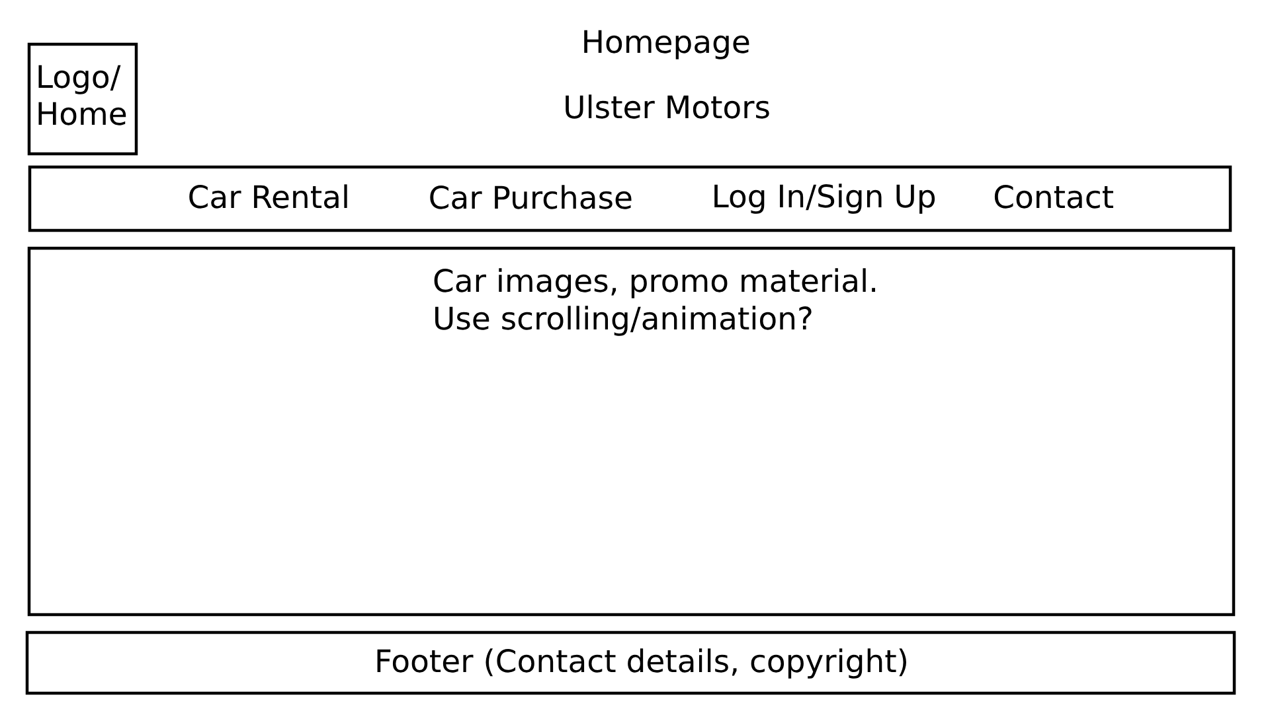

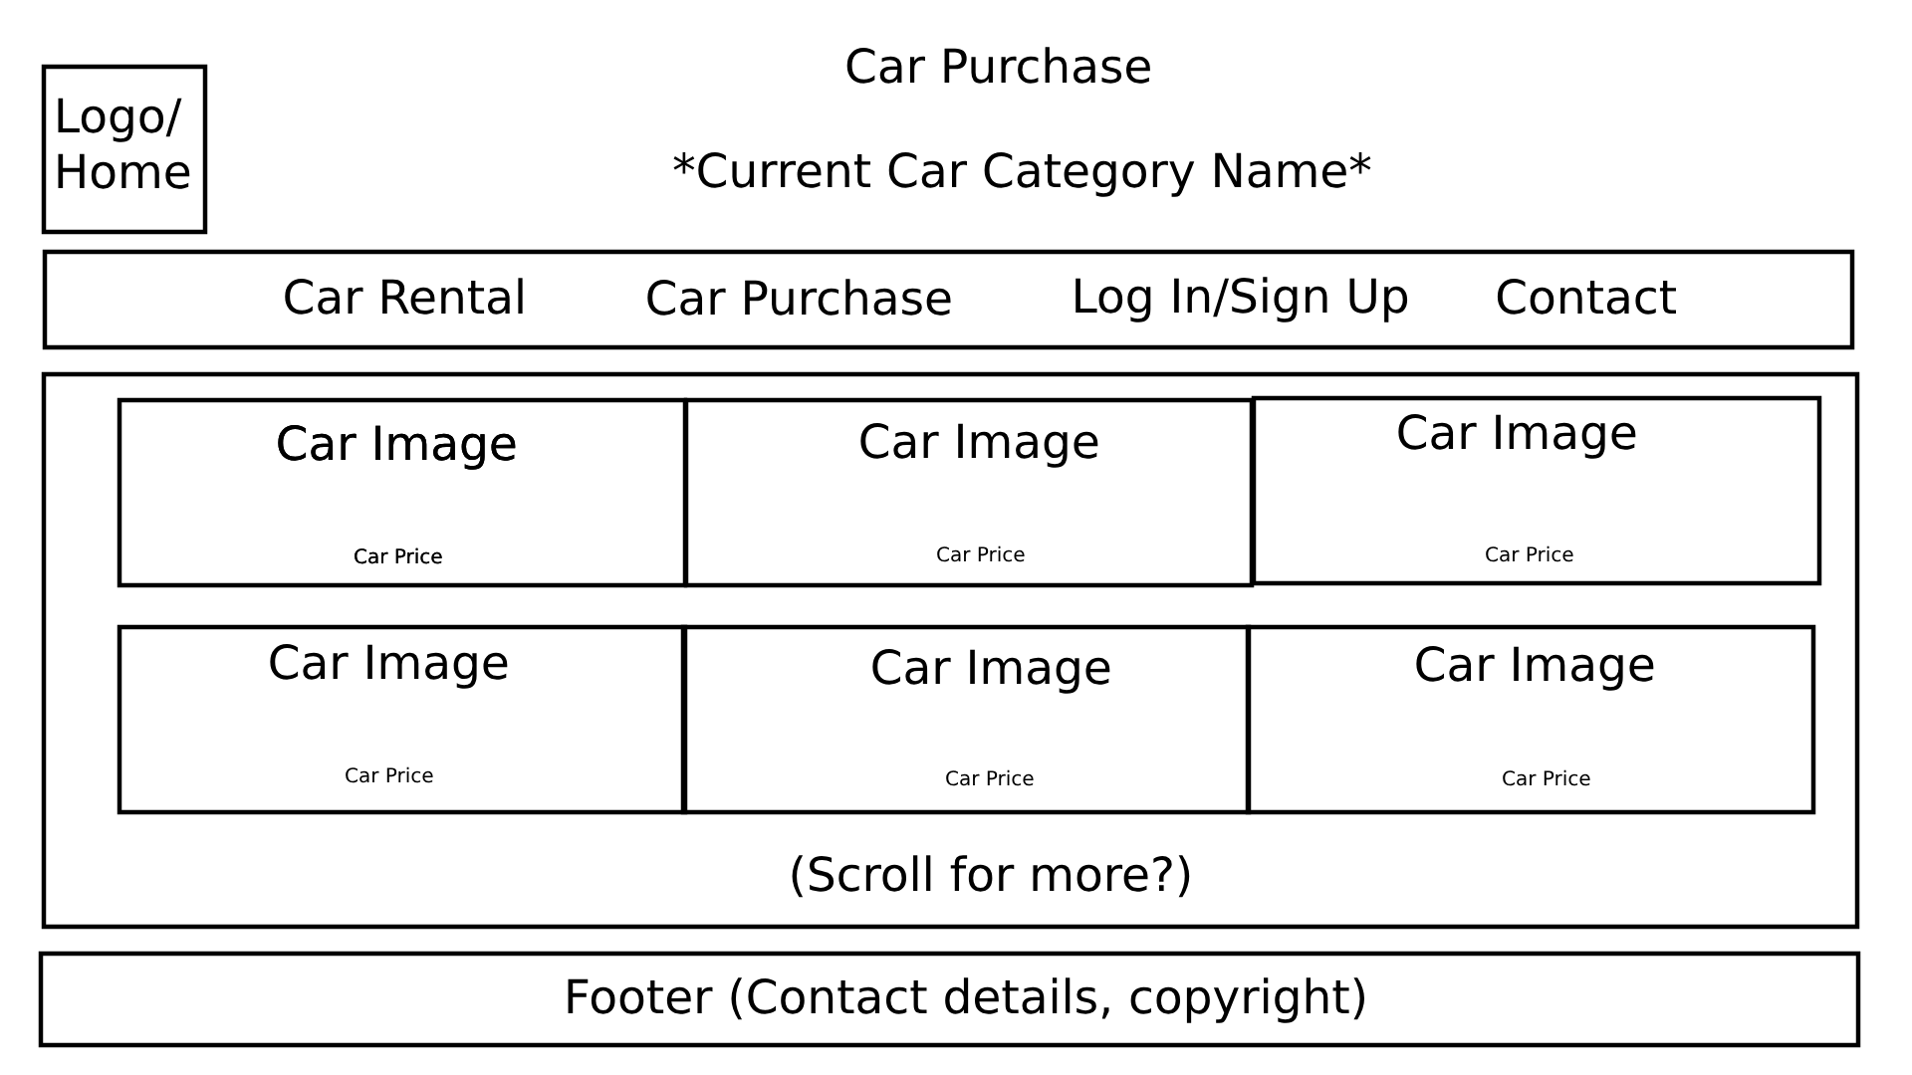

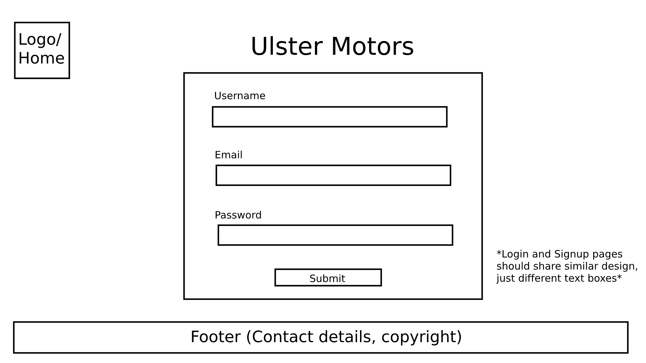

With most of the site content completed we focused on the top index bar. Abhi had already implemented the car categories and dropdowns so we were able to link them to the finished webpages easily. We initially conceptualised the index to have;

- Logo/Homepage

- Car Rental

- Car Purchase

- Contact Us

- Sign Up/Log In

The homepage was coded by Abhi, Nathan and I to have a simple showcase of the cars available. Abhi added a scrolling text marquee to display current news/discounts. Nathan and I modified the HTML to make each image a hyperlink to the corresponding car’s detail page. Some animation was added to the homepage by Abhi and Nathan by using JQuery and a CSS image gallery template (<https://www.w3schools.com/css/css_image_gallery.asp>). The Contact Us page was skipped at this stage as it didn’t showcase any unique functionality.

We coded the Sign In page next. Nathan and I researched how such a page would function and how form validation would be implemented. We settled on these restrictions;

- Email must have an @ to be valid

- Passwords must be over 6 characters

- All fields must be present

Nathan and I implemented the fields while Abhi implemented the validation. We assumed the login page would make good use of cookies, however I suggested that websites usually handle credentials differently. Credentials should usually be saved in a cookie as an encrypted hash of the original string, a session ID/token, or server-side. If our website was deployed live this would be a concern but we simply have to demonstrate the functionality of a cookie. As such it simply stores the login state (“LoggedIn = Yes”) and raw strings of the details the user’s input. I would aim to emphasise security in a future project but simply demonstrating the functionality of this feature is sufficient.

The same approach would be replicated for the purchase screen. I updated each car detail page with a purchase button which would link to the same page that contains purchase details. Again, Abhi implemented the fields while Nathan and I implemented the validation, such as card details requiring 16 characters in numerics only. The details would be validated then saved to a cookie, which automatically navigates to a success screen then a home page redirect. It will not progress if validation conditions are not met.

When necessary functionality was complete, Abhi and I were able to focus on polishing. The CSS was modified to keep a more consistent look across the entire website while adding small changes like colour gradients, image position consistency and keeping the aspect ratio of all car images the same. Some images were manually cropped, upscaled or replaced by suitable alternatives by myself. Nathan was responsible for making the car purchase page look more like a “gallery” with consistent layout sizes. Abhi was also able to make adjustments to our car descriptions to make them more accurate thanks to his knowledge. Additional functionality was also added by Abhi, such as ensuring the user was signed in before making a purchase.

I was responsible for organisation, file structure, and making changes to our code which was previously unorganised. This involved categorising page and asset data, as well as changing all file path names from absolute to relative and changing image file paths to their new locations. This happened towards the end when development was finished as I could not guarantee every file would be in the same place while everyone was collaborating.

Around this time we also settled on the final logo. I created 3 logos, 2 of which were agreed to be too basic and didn’t contrast well with our index colour scheme.

In the end, this is the logo we settled on. It has clear imagery to symbolise what the website is and stands out on most backgrounds we tested.



The favicon was created next – a simple vector greyscale graphic of car keys. Detail is kept to a minimum due to its small size.



These new designs were substituted manually within each piece of code and file by Abhi and I.

When the website was at a functional stage we done a quick test. Site navigation worked (both forwards and backwards), all images were in their correct places and validation was tested to ensure both correct and incorrect values behaved as they should. Cookies also store their intended content.

By this stage of development we were able to reflect on our approach and how we could improve it. While we were all very focused on accomplishing our goal and were able to assign each other tasks to split the workload, we often found it difficult to stay synchronised. We also “learned as we went” so some elements were a trial-and-error process at the beginning. This approach was still vital and helpful in our understanding when putting ideas into execution. Some elements or suggestions were unachievable due to our workflow which slowed down our progress somewhat. For example, ensuring everyone would commit to the GitHub repository constantly so we wouldn’t exclude crucial changes was challenging. I could push changes through a terminal quickly but this was only due to my own familiarity – the other members had to learn from scratch. This made us cautious of every commit made. Organisation also became an issue as I was responsible for maintaining the file structure, but this task had to be done at the very end as I couldn’t organise while everyone else was making changes. Additionally we were assigned a fourth team member, Mya, but she was not present throughout even with attempts to contact her.

The benefit of our approach meant that each person on the team was skilled in something specific – we were able to tailor some tasks to specific team member’s strengths. Abhi was skilled in coding, Nathan was skilled at finding errors and adding features, and I was skilled at asset creation and conceptualisation. We were still each able to contribute to each other’s parts but it could have been made more efficient with a greater emphasis on coordination.

References

Crawford Clarke - <https://www.crawfordclarkecars.co.uk/> - Homepage

Paul Blaney - <https://www.paulblaneymotors.com/> - Homepage

SERE Ltd - <https://www.seremotors.com/> - Homepage